# **Name: Abdurrahman Qureshi**

# **Roll No: 210451**

Practical No: 16

1) Check for ZeroDivisionError Exception.

CODE:

try:  
 A = int(input("Enter a number: A "))  
 B = int(input("Enter another number B: "))  
 Q = A / B  
 print("Quotient", Q)  
except ZeroDivisionError:  
 print("Cant divide by zero")

OUTPUT:

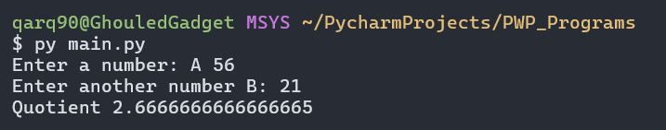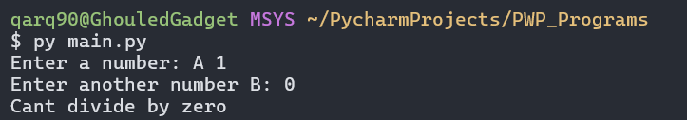

2) Create a user-defined exception that will check whether the entered password is correct.

**CODE:**  
  
class IncorrectPassError(Exception):  
 pass  
  
try:  
 user_pass = input("Enter the password: ")  
 if user_pass != "iLoveGymMommies":  
 raise IncorrectPassError  
 else:  
 print("Access granted!")  
except IncorrectPassError:  
 print("Incorrect password!")

**OUTPUT:**

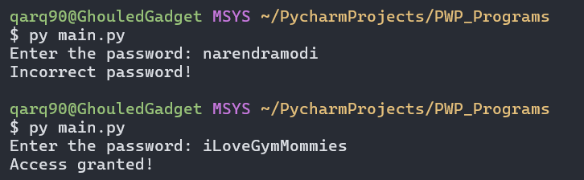

EXTRA QUESTIONS

3) Demonstrate exception handling with the else statement.

**CODE:**

try:  
 A = int(input("Enter a number A: "))  
 B = int(input("Enter another number B: "))  
 Q = A / B  
 print("Quotient:", Q)  
except ZeroDivisionError:  
 print("You can't divide by zero")  
else:  
 print("Zero ya String nahi daalo yaar")

**OUTPUT:**

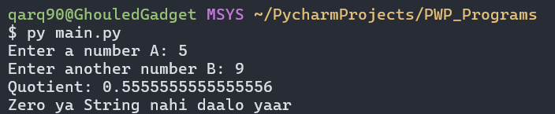

4) Accept the salary and name of an employee and throw an exception in case when negative salary is entered.

**CODE:**

class NegativeSalaryError(Exception):  
 pass  
  
  
class Employee:  
 def get_employee_info(self):  
  
 print("Employee's name:", self.name)  
 print("Employee's salary:", self.salary)  
  
 def set_employee_info(self):  
  
 try:  
 self.name = input("Enter the employee's name: ")  
 self.salary = float(input("Enter the employee's salary: "))  
 if self.salary < 0:  
 raise NegativeSalaryError  
  
 self.get_employee_info()  
 except NegativeSalaryError:  
 print("bhai tumko negative salary kaise milre, kaam karne ka paisa dere kya")  
  
  
e = Employee()  
e.set_employee_info()

**OUTPUT:**

